User Guide – Share Amalgamation Feature

1. Introduction
The Share Amalgamation feature enables administrators to merge shares from one shareholder into another. This helps in:
- Consolidating duplicate shareholder records
- Simplifying ownership structures
- Ensuring accurate and compliance-ready records

2. Navigation
Path:
Records → Companies → Share → View Transaction → Amalg Merge
Note: Available only for Corporate Shareholders
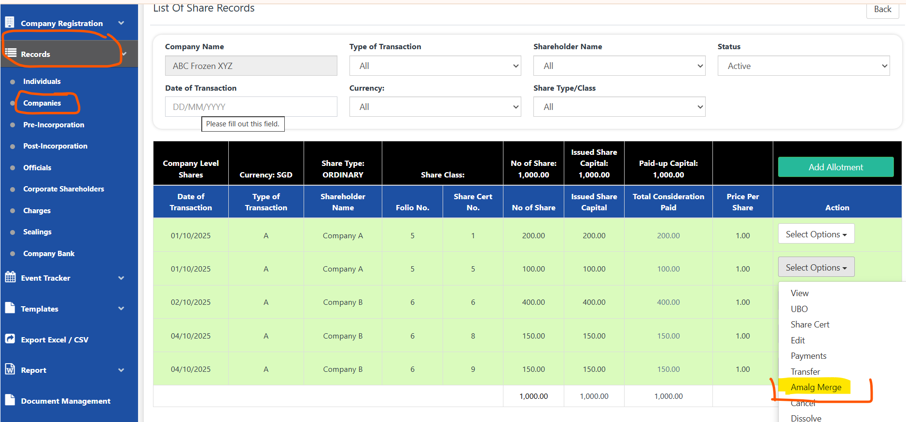

3. Steps to Perform Amalgamation

Step 1 – Select Shareholders
- On the left side (Merge To): Choose the shareholder who will retain the final merged shares.
- On the right side (Amalg From): Choose the shareholder whose shares will be transferred.
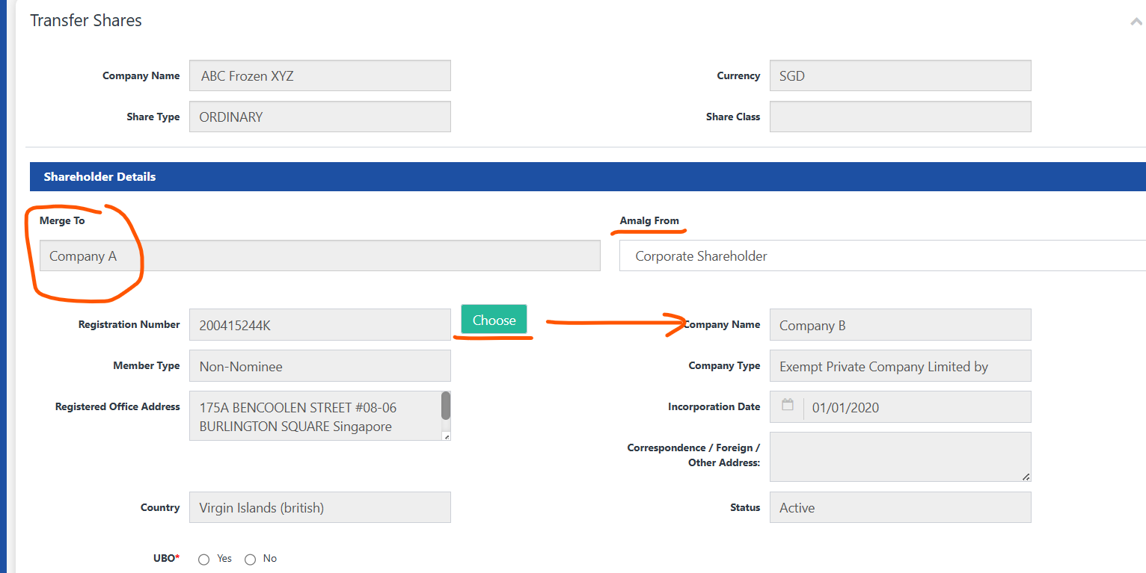

Step 2 – View Combined Share List
The system displays all share records from both shareholders in a single combined list.
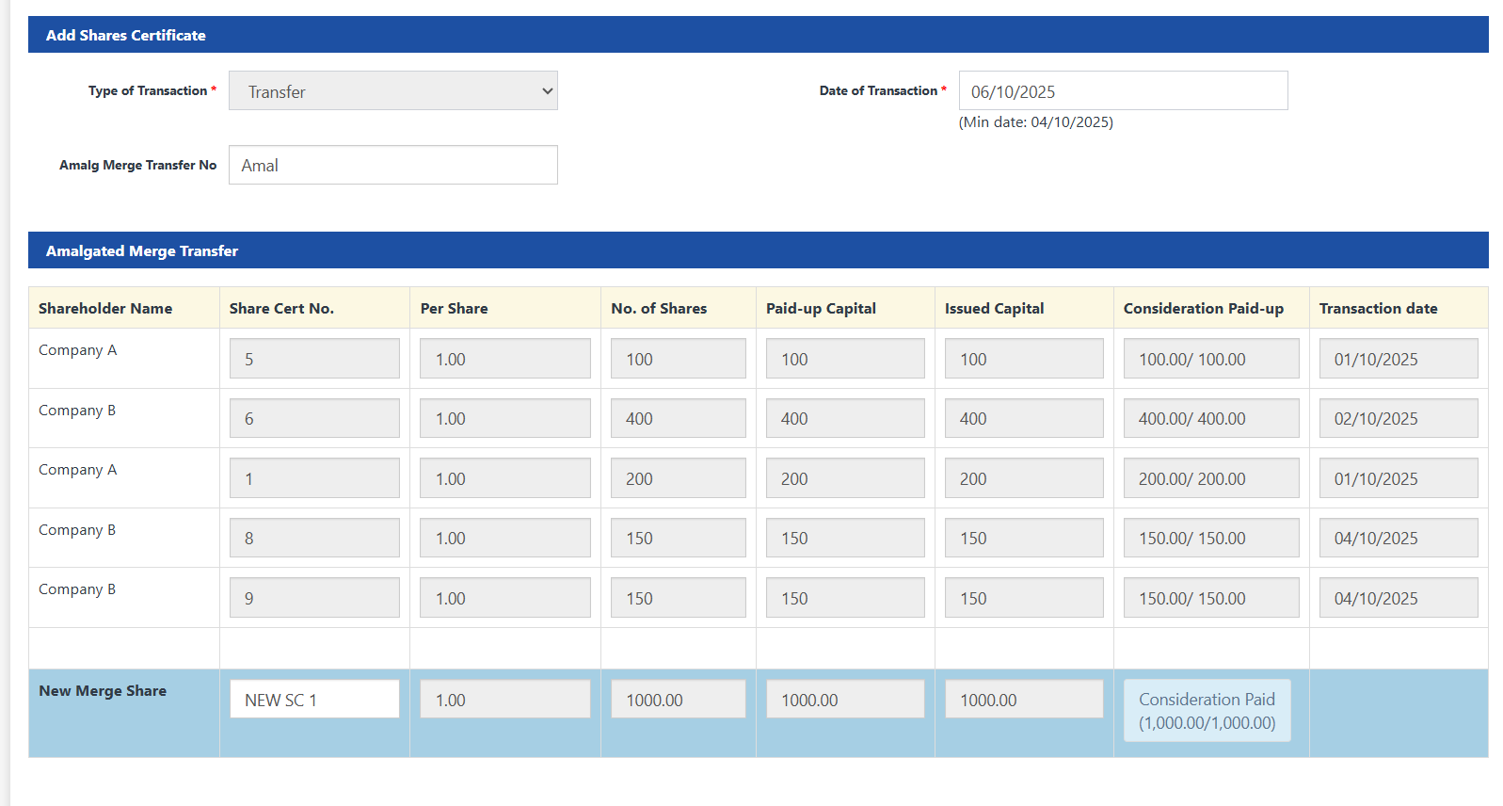

Step 3 – Review Final Merged Row
At the bottom, the system auto-generates a Final Merged Row showing:
- Total combined share value
- Blank field for the new Share Certificate Number

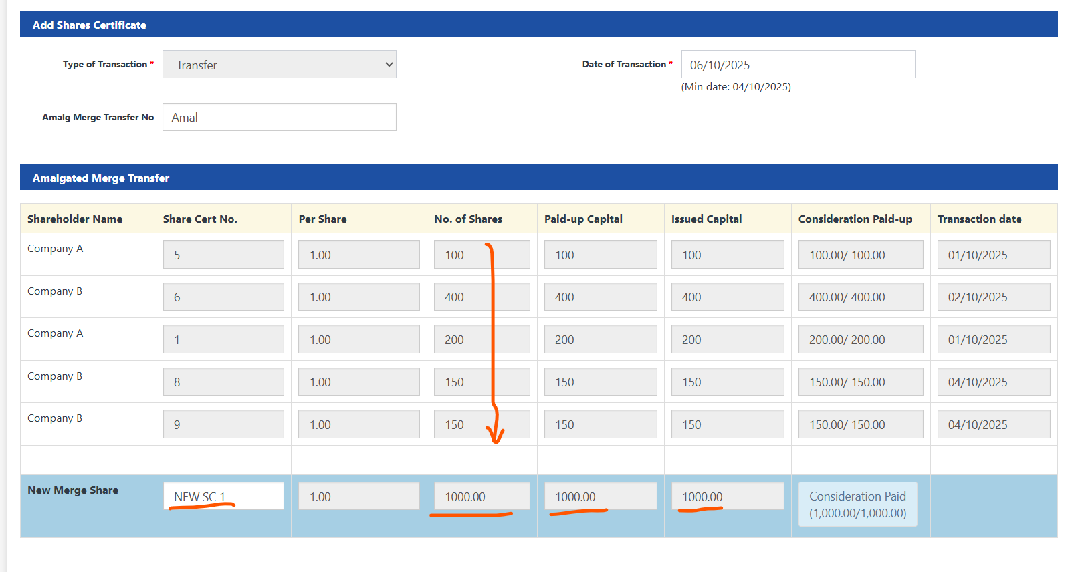Step 4 – Enter Certificate Number
Enter the Share Certificate Number for the merged shares.
eg: “NEW SC1” is a new share certification

Step 5 – Confirm Amalgamation
Click Confirm to complete the process.
The system performs the following automatically:
1. Deactivates the Amalg From shareholder
2. Transfers all shares into the Merge To shareholder
3. Creates a single merged share record with the entered certificate number
4. Updates company name as “XYZ (Amalgamated)” in records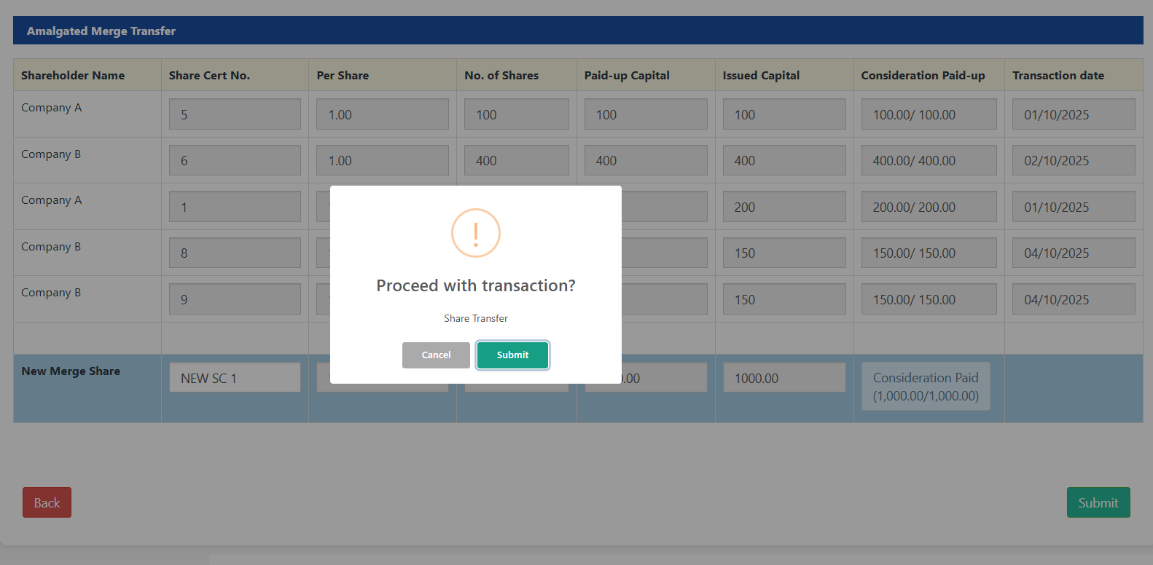
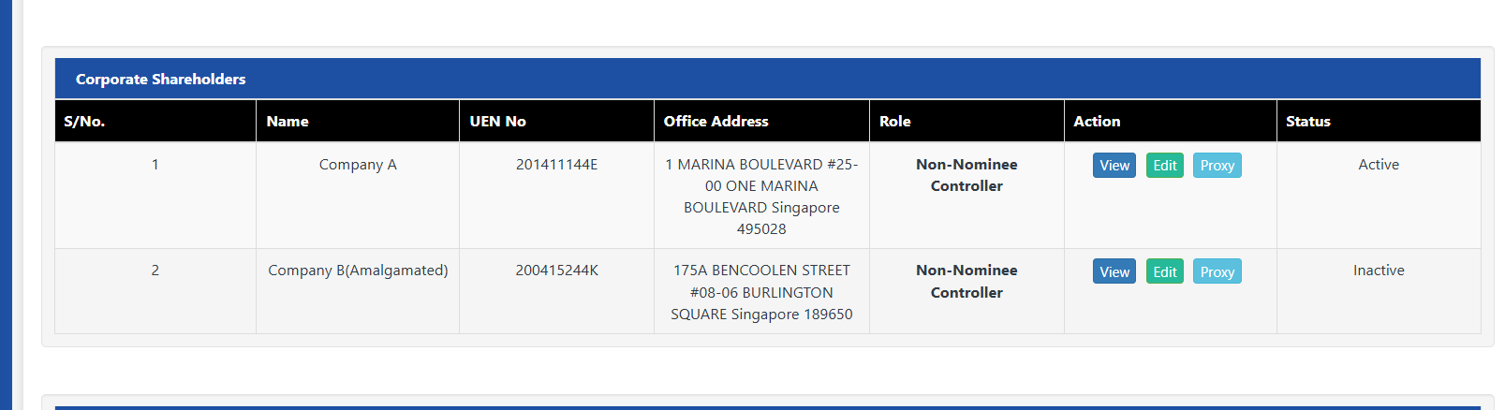

4. Example (ABC Ltd)
Before Amalgamation:
- Shareholder A: 100, 200
- Shareholder B: 400, 150, 150
After Amalgamation (A → B):
- Final Merged Shareholder: B
- Total: 1000
- Certificate No: [Entered by Admin]
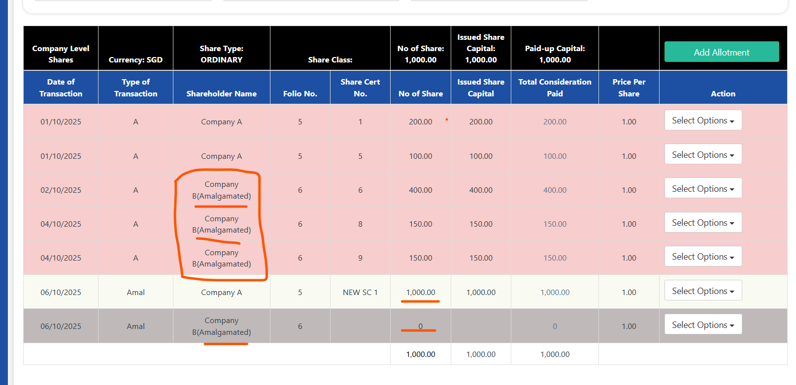

5. Final Outcome
- Amalg From shareholder → Inactive
- Merge To shareholder → Retains consolidated shares
- Records updated as XYZ (Amalgamated)
- Company A can be renamed to Company B on the "Company Edit" page.
